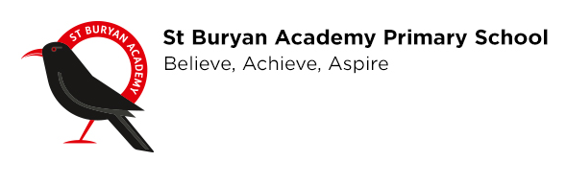
Thursday 16th April 2019

Dear Parent/Carer

Welcome to St Buryan Academy!

Myself and the St Buryan Academy family are delighted that your child has been allocated a place at our wonderful school.
For some of you this will be your first experience of St Buryan Academy, for others you will be making the transition from Little Choughs to Reception – but a big welcome to you all!

I wanted to contact you as soon as possible as I realise that you may have some queries or questions due to the current COVID-19 situation and how this may affect your child starting school.
I wanted to assure you that, as with all of the other children who attend our school, your child is also very much in our staff’s thoughts.

As I am sure you are aware, Britain’s response to COVID-19 is constantly evolving and being assessed. This certainly applies from an education point of view too and at present, our school is closed. However, our staff are working extremely hard from home and are committed to ensuring that the children in our care are still making progress and learning, as well as ensuring that they feel safe and happy.
At St Buryan we are committed to following the Department for Education’s guidance and supporting our children, families and community – which you are part of – in this challenging time for us all.
Currently there are no plans for schools across the country to reopen. Once we are advised on when this will be we will be in touch to provide you with further information regarding how we will support your child’s big milestone of starting school.

Although we find ourselves in uncertain and very different times, I wanted to reassure parents that when the time comes, we will ensure a smooth transition process for your children.
If you have any questions in the meantime, please don’t hesitate to contact myself or the Early Years team: Mrs Cross and Mrs Kwiatkowska. I have included our emails below.

I thank you for your understanding in what is a difficult time for everybody and I want to reassure you that the whole school team are looking forward to your child and yourselves being part of our wonderful school community.

Kind regards

Mr Josh McDonald
Head of School
head@stburyanacademy.org

Mrs Natasha Cross (Early Years and Key Stage 1 Lead)
ncross@stburyanacademy.org

Mrs Joanna Kwiatkowska (SENDCO)
joannak@stburyanacademy.org

St Buryan Academy
Rectory Road
St Buryan
TR19 6BB
www.stburyanacademy.com Tel: 01736 810480

