**SCIENCE:**

We will identify and name a variety of common animals including fish, amphibians, reptiles, birds and mammals, identify and name a variety of common animals that are carnivores, herbivores and omnivores, describe and compare the structure of a variety of common animals, identify, name, draw and label the basic parts of the human body and say which part of the body is associated with each sense. We will have a deeper focus on aquatic animals.

**RE:** What do Christians believe God is like?

Why does Christmas matter to Christians?

**Art :** We will use monochromatic to explore drawing and painting to develop and share their ideas, experiences and imagination. We will develop a wide range of art and design techniques in using pattern, texture, line, shape, form and space.

**Geography:** We will name and locate the world’s seven continents and five oceans, name and locate the four countries and capital cities of the UK, understand geographical similarities and differences both human and physical.

**Under the Sea !**

***What lives within the ocean?***

**Showcase: A classroom aquarium.**

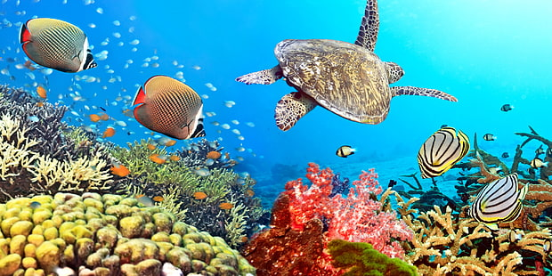

**WRITING:**

SPAG – understand verbs, nouns, collective nouns, compound nouns and proper nouns. Apply this knowledge to writing and punctuating independent clauses. Use co-ordinating conjunctions to join independent clauses.

Non-chronological reports on Sea Creatures.

Increase writing stamina.

**READING:**  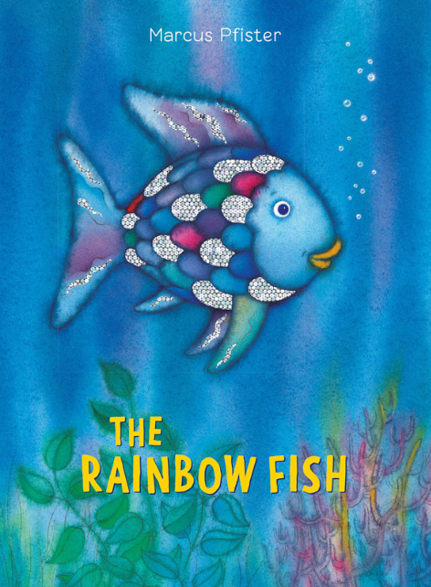 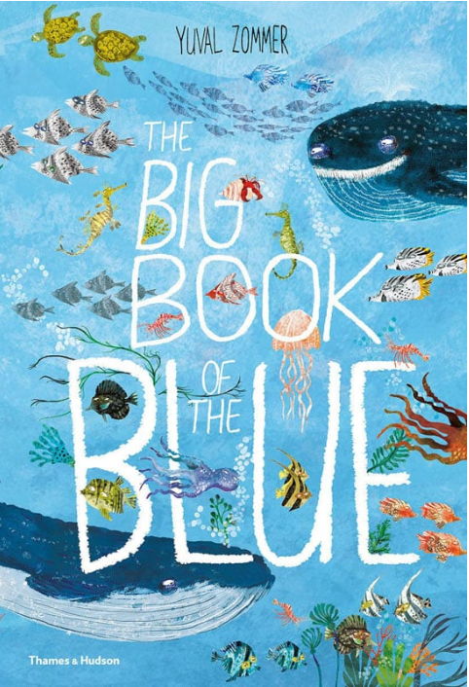

**PE:** We will be covering team games with a focus on ball techniques and then a unit of football.

**MATHEMATICS:**

Year 2 blocks – Money, Fractions, Time, Mass, capacity and temperature and Position and direction.

Year 3 blocks – Time, Decimals, Money, Shape, Position and direction and Statistics.