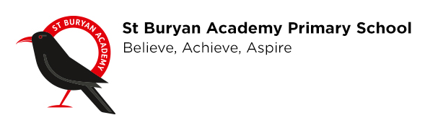
Dear Parents/Carers
With the prospect of self-isolation and the possibility that schools may close nationwide in the coming weeks, we have set up some home learning activities for your children to participate it.

Should schools shut during term time, we are obliged to set work for your children and they are expected to complete it.

We have set up Google Classrooms for children to interact with and still meet the needs of the curriculum in the event of any closure. Even if schools do not close, this is still a great way to access any learning.

In order to interact with Google Classrooms you must follow the steps below. You should receive an email giving you steps to follow, but should you not receive one I have made this simple guide:
-Go to classroom.google.com and click Go to Classroom
-Create an account and accept the welcome message
-Click the ‘I’m a student’ tab
-Join a class by entering the code in the table below. Each class has a different code.
-When you are in your ‘Class’ you will be able to access all of the learning and work that your teacher has uploaded for you to complete

We appreciate that not everyone will have regular internet access, so we will do our upmost to offer alternative options, however this may not always be possible.

I understand that some may consider measures to be extreme, but I would much rather we are proactive to matters than reactive and fulfill our duty of providing your children with the best education we are able to do. Work will be uploaded over the coming days.

Thank you for your understanding and co-operation

Mr Josh McDonald
Head of School
St Buryan Academy
head@stburyanacademy.org

Class | Login Code
Penberth | 4uchh27
Gwenver | baak7x3
Nanjizal | lmcp25s
Porthcurno | mcd3257

