year 6 Spring term plan: journeys

The topic ‘Journeys’ allow us to explore a wide range of learning opportunities. Geographically, we can look at journeys that have been made to discover new lands, like Christopher Columbus. We can also look at the journeys of water cycles, mountain formation and erosion. More topically, we can also look at migrants and why people move countries for different reasons. Science allows us to study the changes we make as humans, both on the inside and out. We can look at life processes as well as the journey materials may make if they change state. Our literacy allows us to follow books and poems that involve journeys, both physically and metaphorically; The Lord of the Rings is a prime example of this. In maths we can use real life journeys to find out distances, measurement, money and time; applying our learning to the real world and solving problems in the process. In history we can follow the journeys famous and inspirational people have made throughout their lives.
Science
In science this term we will link our topic, Journeys, to our points of learning. We will look at how to classify characteristics of living things (inc. micro-organsims, plants and anumals). We will also look at the human circulatory system, describing the parts of the heart and its functions, looking athow blood makes the journey it does through our body.
We will look at the impact of diet, exercise, drugs and lifestyle impact our own lives and bodies.
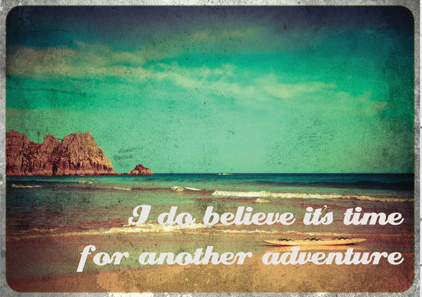
Our journey topic will run from January to April and, perhaps most importantly, we will follow the journey we make together as a class, as well as individuals.
PSHE
This term’s PSHE we will focus on our futures and what career choices we may make. We will look at what you need to achieve your dreams and aspirations. We will practice our Curriculum Vitae and letters to employers. We will learn what skills we need and practice them.
One of our main aims is to hold a Careers Day and invite people from different careers into school to speak to year 6 about what skills they need to achieve in that career and running a short workshop with them. We would look to invite several different professions into school.
Physical Education
This term we will continue with Dance and Swimming each Thursday and Friday respectively. Mrs Prowse, our dance teacher, will use our topic to influence their dance routines this term. We will get to know how our bodies move and work through movement and gymnastics.
REAL Project, Immersive Learning Environments and other learning opportunities.
After winning a competition with Pirate FM, we had a VIP visit to their station. Following the visit they approached us as a primary school that they would like to work with – a very unique and rare opportunity as the work they do with primary schools is extremely rare and limited. We would tie the experience in with our own topic and learning. The learning opportunities are unique for this age and would allow the children to apply their learnt knowledge to real life and finish with a great piece of work for an authentic audience. Opportunities include: creating radio shows and interviews on careers, looking at different roles and production jobs within journalism and radio, creating a radio show for a Pirate FM platform and an advert for the school website and social media, adverts about themselves and an audio portfolio on themselves.
During this time the classroom will be transformed into a radio station to allow our learning environment to be as immersive as possible.
Humanities
Journeys allow us to explore the journey migrants make from one place to another; whether it be continents, countries or places within a country. We can look at the reasons as to why people travel or migrate and the impact it has on our country as well as the country they have left. We can debate what can be done to help immigrants and what we can do to help illegal immigrants. In history we can look at great adventurers and explorers, studying the routes they travelled and the lands they found.
Maths
We will continue to follow the Abacus planning for our Maths curriculum, we will also begin to look at Hegarty Maths, designed to reinforce our knowledge where it may be lacking.
For a more detailed maths plan, please so our Class Abacus Maths Folder or visit our website for weekly updates.
Literacy
In English this term we will be using our visit from author, Billy Bob Buttons, to help inspire our own story-writing. Our story writing will be about Journeys, gaining inspiration from books such as The Hobbit and Lord of The Rings, The Life of Pi, Alice in Wonderland, The Wizard of Oz and more. We will also look at narrative poems like The Jabberwocky and Dr Suess’ poem, ‘Oh, the places you’ll go.’
As well as the above, we will be looking at our punctuation and grammar and reading comprehension in preparation for our SATs.

