

ALLERGY POLICY

This is a Category B policy. It applies to all schools in the Trust, with school-specific elements approved by the Local Academy Committee.

Last review date | October 2025
Date approved by the Chief Executive Officer on behalf of Trust Board | October 2025
Date for next review | October 2026

Approved by St Buryan Academy Primary Local Academy Committee for the (2025/26) academic year

Document Control

Document version numbering will follow the following format. Whole numbers for approved versions, eg 1.0, 2.0, 3.0 etc. Decimals will be used to represent the current working draft version, eg 1.1, 1.2, 1.3 etc. For example, when writing a procedural document for the first time the initial draft will be version 0.1.

The table below provides details of the changes made to this document, to inform those reviewing and approving the document.

Document Edition | Section | Details of Change
0.1 | All | New policy drafted using model templates and guidance from Anaphylaxis UK, Allergy UK, Allergy School and The Key.
1.0 | All | Approved by the Chief Executive Officer on behalf of Trust Board, October 2025.

Table of Contents

1. Introduction 6
2. Policy statement and aims 6
3. Equalities Statement 7
4. Legislation, statutory requirements and statutory guidance 7
5. Roles and responsibilities 7
6. Assessing risk 11
7. Managing risk 12
7.1 Training 12
7.2 Catering 13
7.3 Other food in school 13
7.4 Supply, storage and care of medication 14
8. Inclusion and safeguarding 15
9. Useful Links 15
APPENDICES 17

Introduction
The Leading Edge Academies Partnership (the ‘Trust’) is a group of six distinct and unique schools located in beautiful coastal and island settings in Cornwall and the Isles of Scilly. We are fortunate to include a mix of primary and secondary schools, as well as an all-through school with boarding provision and off island bases. This diversity makes for a dynamic and varied perspective.
We offer a values-based education to the communities we serve and welcome employees, pupils, parents/carers and volunteers from all different ethnic groups and backgrounds. The Trust achieves its vision and mission through co-construction, with everyone empowered to shape the future and contribute towards the Trust’s success.
The term ‘Trust Community’ includes all employees, trustees, governors, pupils, parents/carers, volunteers and visitors.
We are a values-based Trust, which means all actions are guided by our three ‘Es’ as follows:
- Excellence – ‘Outstanding quality’
- Evolution – ‘Continuous change’
- Equity – ‘Fairness and social justice’

This policy is based on the values of ‘Equity’ and ‘Excellence’

Policy statement and aims
Around 5-8% of children in the UK live with a food allergy and most school classrooms will have at least one allergic pupil. These young people are at risk of anaphylaxis, a potentially life-threatening reaction which requires an immediate emergency response. 20% of severe allergic reactions to food happen whilst a child is at school and these reactions can occur in children with no prior history of food allergy. It is essential that staff recognise the signs of an allergic reaction, symptoms and are able to manage it safely and effectively.
St Buryan is committed to promoting a whole school approach to health care, welfare and wellbeing and the safe management of those members of our school community who live with specific allergies. We believe that all allergies should be taken seriously and dealt with in a professional and appropriate way.
This policy aims to:
- Set out our school’s approach to allergy management, including reducing the risk of exposure and the procedures in place in case of allergic reaction
- Make clear how our school supports pupils with allergies to ensure their wellbeing and inclusion and encourage self-responsibility
- Promote and maintain allergy awareness among the school community
Related policies
This policy should be read in conjunction with other relevant Trust and school policies including:
- Supporting Students with Medical Needs
- Health and Safety (including First Aid)
- Dogs on school premises

Equalities Statement
St Buryan Academy Primary is committed to actively supporting pupils with medical conditions to participate fully and safely in school life.
Where necessary, we will undertake risk assessments so that planning arrangements take account of any steps and/or reasonable adjustments needed to ensure that pupils with medical conditions are included. In doing so, pupils, their parents and any relevant healthcare professionals will be consulted.

We will ensure pupils/students from diverse backgrounds, ethnicities or different cultural heritages are not disadvantaged when dealing with allergies and food labelling.

Legislation, statutory requirements and statutory guidance

Schools have a legal duty to support pupils with medical conditions, including allergy. Schools must adhere to legislation and statutory guidance on caring for pupils with medical conditions, including the administration of allergy medication and adrenaline auto-injectors.
This policy is based on the Department for Education (DfE)’s guidance on allergies in schools and supporting pupils with medical conditions at school, the Department of Health and Social Care’s guidance on using emergency adrenaline auto-injectors in schools, and the following legislation:
- The Food Information Regulations 2014
- The Food Information (Amendment) (England) Regulations 2019

Roles and responsibilities
5.1 The Trust
The Trust has ultimate responsibility for ensuring schools have effective arrangements in place to support pupils with medical conditions, including ensuring that sufficient staff have received suitable training and are competent before they are responsible for supporting children with medical conditions.

The Trust will:

- Ensure the school has a strategic vision for the management of allergy risk assessment and emergency procedures.
- Ensure the school's arrangements to identify and safeguard the wellbeing of pupils, because of their own or someone else's allergy, are robust and effective.
- Delegate the day-to-day responsibility for the effective implementation delivery of this Policy to the Headteacher/Principal.
- Ensure that the school provides appropriate training, information, instruction, induction and supervision on a regular basis to enable everyone to stay safe regarding allergies and their management.
- Ensure adequate resources for managing allergies are available.
The Trust will regularly review this policy and will monitor implementation of the policy in all Trust schools. Implementation of the policy at school level will also be monitored by the Local Academy Committee.
5.2 Headteacher/Principal
The Headteacher/Principal will:
- Have delegated responsibility for ensuring full and effective implementation of this policy in the school.
- Provide, as far as practicable, a safe, healthy and inclusive environment in which people at risk of allergic reaction and anaphylaxis can participate equally in all aspects of school life and are not subject to bullying because of their condition
- Make sure all staff are aware of this policy and understand their role in its implementation.
- Oversee staff training and ensure that there is a sufficient number of trained staff available to implement this policy and deliver against all Individual Healthcare Plans (IHPs) and Allergy Action Plans (AAPs), including in contingency and emergency situations.
- Ensure that all staff who need to know are aware of a child’s allergy and where relevant their IHP and AAP.
- Ensure that robust systems are in place for obtaining, recording and updating information about a child’s medical needs, including IHPs and AAPs, and that this information is kept up to date, in line with the Supporting Students with Medical Needs Policy.
- Oversee the storage of all medicines, including ensuring that medicines are in date and arranging appropriate disposal.
- Ensure there are clear processes for communication with staff, parents and other stakeholders regarding the school’s policies for allergy management, such as the policy on packed lunches and food from home, and that appropriate material is available on the school website.
- Appoint an Allergy Lead with delegated day-to-day responsibility for managing the needs of pupils with allergies. The Allergy Lead for St Buryan Academy Primary School is Joshua McDonald (Head of School).
- Report to Governors/Trustees regarding the management of allergies within the school
- Ensure all visitors, volunteers, work experience students, sub-contractors are made aware of the school's commitment to allergy management as part of Safeguarding
- Ensure the curriculum contains age-appropriate content so all pupils/students can learn about allergies and how everyone can support those who have them
- Create links at strategic level with healthcare professionals and catering providers and ensure at operational level that links are robust
- Ensure there are robust risk assessment arrangements prior to any school trips, excursions or off-site extra curricula activities for pupils/students who have allergies
- Ensure that there are robust arrangements in place by catering providers / catering teams in relation to food labelling, storage and avoidance of cross-contamination.

5.3 Allergy lead
The Allergy Lead for St Buryan Academy Primary School is Joshua McDonald.
The Allergy Lead has delegated day-to-day responsibility for managing the needs of pupils with allergies. Although the allergy lead has overall responsibility, some information collection and management may be undertaken by administrative staff.
The Allergy Lead will:
- Promote and maintain allergy awareness across our school community
- Promote awareness of all staff of the school’s policy and procedures regarding allergies
- Liaise with parents/carers of pupils/students with known declared allergies to produce a risk assessment for their child that includes sharing of information, allergy management, risk minimisation and emergency actions.
- Record, collate and update allergy and special dietary information for all relevant pupils, including in their Individual Healthcare Plan (see Supporting Students with Medical Needs Policy)
- Work with parents/carers and healthcare professionals to ensure that wherever possible all pupils with allergies have an allergy action plan (AAP) completed by a medical professional
- Ensure AAPs are kept with a pupil’s medication where relevant, and that up-to-date copies of the AAP are easily available for staff to access.
- Ensure allergy information is up to date and readily available to relevant members of staff
- Ensure all staff receive an appropriate level of allergy training, including their identification and management
- Keep stock of both pupils’ and the school’s adrenaline auto-injectors (AAIs) and ensure these are stored, checked and disposed of appropriately in line with this policy.
- Ensure relevant staff are aware of what activities need an allergy risk assessment.
- Report to the Headteacher/Principal regarding pupils with allergies.
- Liaise with parents of pupils with known allergies and in-house or sub-contracted Catering Managers to identify allergies any special requirements, including arranging joint meetings where necessary. Ensure that updated information or requirements are communicated to Catering Managers as necessary.
- Ensure that robust risk assessments are undertaken prior to any school trips, excursions or off-site extra curricula activities for pupils who have allergies and contribute to such risk assessments as appropriate.

5.4 Staff
Staff will:
- Maintain awareness of our allergy policy and procedures
- Follow as directed all the requirements of the school, including all legal requirements, recommended best practice and whole school procedures pertaining to allergies within the school context
- Complete appropriate training as required, be able to recognise the signs of severe allergic reactions and anaphylaxis, and be confident to respond to an allergy emergency
- Be aware of specific pupils with allergies in their care.
- Carefully consider the use of food or other potential allergens in lesson and activity planning
- Ensure the wellbeing and inclusion of pupils with allergies
- Promote awareness about allergies and anaphylaxis amongst their pupils in the classroom and around school, especially in dining areas
- Encourage self-responsibility and learned avoidance strategies amongst pupils living with allergies
- Help all pupils understand which foods are safe for those with allergies and how they can support other pupils with specific dietary needs to stay safe
- Be vigilant against the risk of bullying for pupils with allergies
- Supervise any food-related activities with due caution whilst following best practice for storing, preparing, cooking and serving food
- Ensure that for any school trips, excursions or off-site extra-curricular activities they, or the pupil themselves where appropriate, carry all relevant emergency supplies with them

5.5 Parents/carers
Parents/carers will:
- Provide the school with up-to-date details of their child’s allergies, medical needs, dietary requirements, and any history of allergies, reactions and anaphylaxis
- Inform the school of any changes as soon as known
- Contribute to the provision of an IHP in partnership with the school, and relevant healthcare professionals, where required.
- Wherever possible, provide an AAP completed by a healthcare professional that can be kept with their child’s medication
- Provide any other written medical documentation, instructions and medications as directed by a health professional.
- Be aware of our school’s allergy policy
- Talk with their child age-appropriately about allergy self-management, including what foods are safe and unsafe, how to read food labels, strategies for avoiding allergens, how to spot symptoms of allergy, how and when to tell an adult if experiencing an allergic reaction.
- Meet with the Allergy Lead and Catering Manager where required to discuss any specific requirements relating to their child's allergy
- Be aware of the school Allergy Policy and any arrangements for managing children with allergies and at risk of anaphylaxis
- If required, provide their child with 2 in-date adrenaline auto-injectors and any other medication, including inhalers, antihistamine etc., and make sure these are replaced in a timely manner
- Provide appropriate foods to be consumed by the child if necessary
- Follow the school’s policy on food and drink they provide to their child as packed lunches and snack, including labelling
- Follow the school’s policy on food brought in to be shared

5.6 Pupil with allergies (as age appropriate)
Pupils with allergies will:
- Have a good awareness of their allergy and support the knowledge of peers in helping keep them safe
- Be proactive in the care and management of their food allergies and reactions and medication
- Understand how and when to use their adrenaline auto-injector, know where it is kept, and carry it with them where it is appropriate and agreed in their IHP.
- Be sure not to exchange food with others and take care to avoid any foods which may cause an allergic reaction
- Read food labelling but, if unsure, avoid the food
- Avoid eating anything with unknown ingredients
- Tell an adult as soon as they suspect they are experiencing signs of allergic reaction.

Assessing risk
Where the school is notified that a pupil has one or more allergies, the Allergy Lead will take responsibility for undertaking a risk assessment for the pupil in liaison with parents/carers that includes sharing of information, allergy management, risk minimisation and emergency actions.
Risk assessment templates are available from Anaphylaxis UK
The risk assessment will include (but is not limited to) the risks to the pupil in relation to:
- Breaktimes and lunchtimes
- Lessons such as food technology
- Science experiments involving foods
- Crafts using food packaging
- Any other activities involving animals or food, such as animal handling experiences or baking
- Insect bites/stings
A separate risk assessment will be undertaken prior to any school trips, excursions or off-site extra curricula activities for pupils who have allergies.
A risk assessment for any pupil at risk of an allergic reaction will also be carried out where a visitor requires a guide dog.
The Allergy Lead will record, collate and update allergy and special dietary information for all relevant pupils, including in their Individual Healthcare Plan (see Supporting Students with Medical Needs Policy) where appropriate.
Allergy Action Plans have been designed to facilitate first aid treatment of anaphylaxis, to be delivered by
people without any special medical training nor equipment apart from access to an adrenaline
auto-injector (AAI). The plans are medical documents, and should be completed by a child’s health
professional (and not by parents or teachers). The plans may function as IHPs for children with allergies.
Where necessary, and wherever possible, parents will be asked to provide an AAP completed by a healthcare professional that can be kept with their child’s medication.

Managing risk

7.1 Training
As a minimum, a sufficient number of trained staff will always be available to implement this policy and deliver against all Individual Healthcare Plans (IHPs) and Allergy Action Plans (AAPs), including in contingency and emergency situations.
However, the school is committed to training as many staff as possible in allergy awareness and response, with the ultimate aim of training all staff.
Training will include:
- Knowing the common allergens and triggers of allergy
- Measures to reduce the risk of a child having an allergic reaction e.g. allergen avoidance
- Spotting the signs and symptoms of an allergic reaction and anaphylaxis. Early recognition of symptoms is key, including knowing when to call for emergency services
- The importance of acting quickly in the case of anaphylaxis
- Administering emergency treatment (including AAIs) in the event of anaphylaxis – knowing how and when to administer the medication/device
- Where AAIs/medication is kept on the school site, and how to access them
- The wellbeing and inclusion implications of allergies
- Understanding Allergy Action Plans
Allergy training should be refreshed annually (at a minimum) and new and temporary staff should be trained as soon as possible to ensure confidence and competence.

7.2 Catering
All food businesses (including school caterers) must follow the Food Information Regulations 2014 which states that allergen information relating to the 'Top 14' allergens must be available for all food products, including those pre-packaged for direct sale (PPDS).
For schools with third-party catering contracts, caterers must abide by these regulations as a condition of their contract.
For schools with in-house catering arrangements, it is the responsibility of the Catering Manager to ensure that these regulations are abided by.
All catering staff must follow hygiene and allergy procedures when preparing food to avoid cross-contamination.
The Allergy Lead will liaise with parents of pupils with known allergies and in-house or sub-contracted Catering Managers to ensure caterers are aware of identified allergies and any special requirements, including arranging joint meetings with parents where necessary.
Catering staff will be able to identify children with allergies by documentation held securely.
The school menu is available for parents to view in advance with all allergens listed and allergens highlighted on the school website at www.stburyanacademy.com in line with Aspen’s policies.
Where appropriate the pupil should be taught to also check with catering staff before purchasing food or selecting their lunch choice.

7.3 Other food in school
Lunchboxes, bottles and other food or drinks items provided by parents for pupils should be clearly labelled with the name of the child for whom they are intended. This is particularly important for children with food allergies.
St Buryan Academy operates a strict no-nuts policy to protect students with severe nut allergies. This means that foods containing nuts are prohibited from all school premises. This includes:
- Packaged nuts
- Cereal, granola or chocolate bars containing nuts
- Peanut butter or chocolate spreads containing nuts
- Peanut-based sauces, such as satay
- Sesame seeds and foods containing sesame seeds
St Buryan Academy prohibits cakes, baked goods, and food items being brought into school for birthday celebrations or special events to prevent allergen exposure and cross-contamination risks. Any food for school events must be pre-approved by the Allergy Lead.
Where food is provided by the school, staff should be educated about how to read labels for food allergens and instructed about measures to prevent cross contamination during the handling, preparation and serving of food. Food should not be given to primary school age food-allergic children without parental engagement and permission (e.g. food treats). If in any doubt staff should check with the Allergy Lead.

7.4 Supply, storage and care of medication
Medication relating to allergies will be transferred, managed and stored in line with the Supporting Students with Medical Needs Policy.
Where a pupil is known to be at risk of anaphylaxis, parents will be asked to provide two Adrenaline Auto-Injectors (AAIs). It is parents’ responsibility to ensure these are within the expiry date, although the school may make its own regular checks and send a reminder to parents if approaching expiry date. Parents are encouraged to register the AAIs with the manufacturer to receive text alerts for expiry dates.
Depending on their level of understanding and competence, pupils will be encouraged to take responsibility for and to carry their own two AAIs on them at all times (in a suitable bag/container). This should be detailed in their IHP/AAP. However, symptoms of anaphylaxis can come on very suddenly, so school staff need to be prepared to administer medication if the young person cannot.
For younger children or those not ready to take responsibility for their own medication, there should be an anaphylaxis kit which is kept safely, but not locked away, and accessible to all staff.
Medication should be stored in a suitable container and clearly labelled with the pupil's name and photograph. The pupil's medication storage container should contain:
- Two AAIs i.e. EpiPen® or Jext®
- An up-to-date allergy action plan
- Antihistamine as tablets or syrup (if included on allergy action plan)
- Spoon if required
- Asthma inhaler (if included on allergy action plan).
Staff leading school trips will ensure they, or the pupil where appropriate, carry all relevant emergency supplies and medication.
Storage
AAIs should be stored at room temperature, protected from direct sunlight and temperature extremes.
AAIs are single use only and must be disposed of as sharps. Used AAIs can be given to ambulance paramedics on arrival or disposed of in a sharps bin.
The sharps bin is kept in the staff room.

Spare AAIs and asthma inhalers
The school has purchased spare AAIs for emergency use in children who are risk of anaphylaxis, but their own devices are not available or not working (e.g. because they are out of date) or are experiencing anaphylaxis for the first time. Spare pens must be kept safely, but not locked away, and accessible and known to all staff.
Spare AAIs are stored in:
Staff Room
They are in the grey bin clearly labelled ‘Emergency Anaphylaxis Adrenaline Pen’.
The Allergy Lead is responsible for checking the spare medication is in date on a regular basis and replacing as needed.

Inclusion and safeguarding
Our school is committed to ensuring that all children with medical conditions, including allergies, are properly supported in school in terms of both physical and mental health so that they can play a full and active role in school life, remain healthy and achieve their academic potential.
For more information see our Anti-Bullying Strategy.

Useful Links
Department for Education Allergy Guidance for Schools

Anaphylaxis UK - https://www.anaphylaxis.org.uk/

Safer Schools Programme - https://www.anaphylaxis.org.uk/education/safer- schools-programme/

AllergyWise training for schools – specialized school-focused training programs

AllergyWise for Schools online training - https://www.allergywise.org.uk/p/allergywise-for-schools1

Allergy UK - https://www.allergyuk.org

BSACI Allergy Action Plans - https://www.bsaci.org/professional- resources/resources/paediatric-allergy-action-plans/
Spare Pens in Schools - http://www.sparepensinschools.uk

Department for Education guidance on Supporting Pupils with Medical Conditions at School

Department of Health and Social Care guidance on the use of Adrenaline Auto-injectors in Schools
Food Standards Agency Food Allergy and Intolerance Online Training

APPENDICES

Appendix I - First Aid for Anaphylaxis Poster

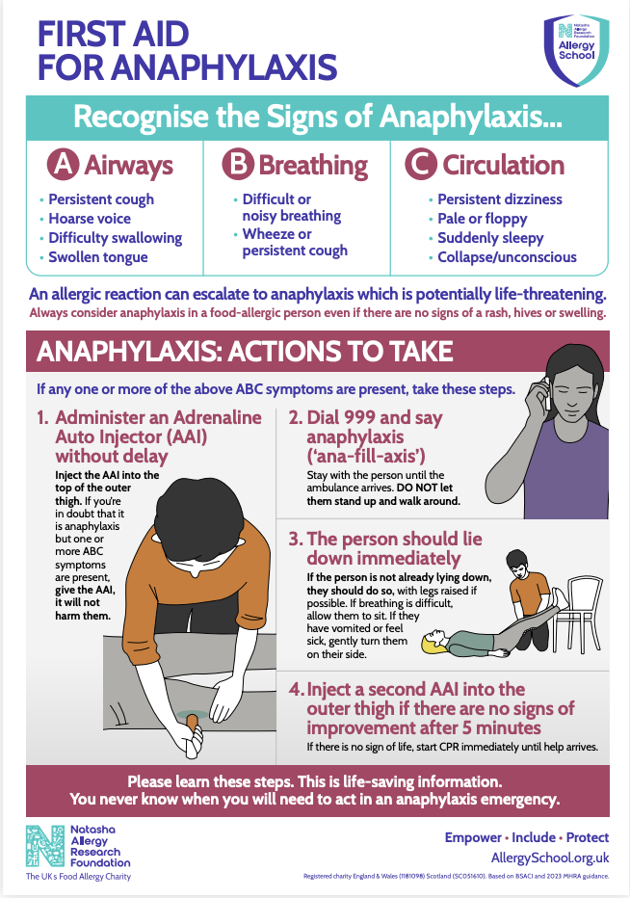

Appendix II

EpiPen AAI and Jext AAI Instructions

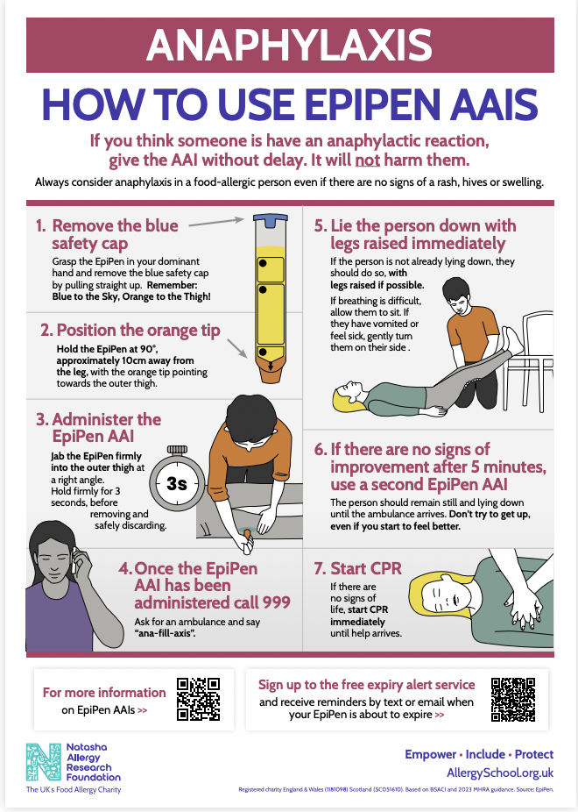

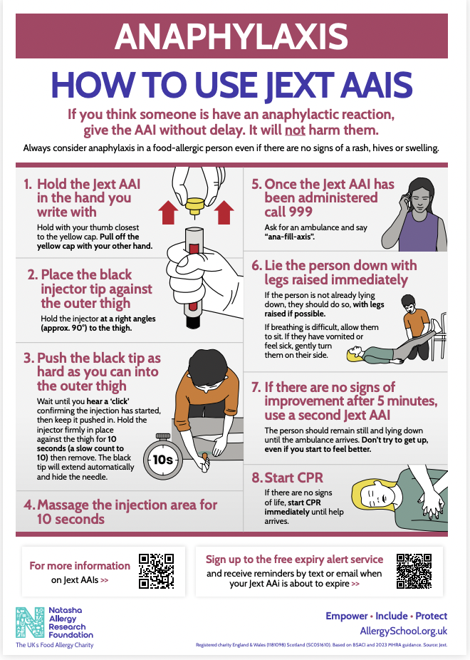

Appendix III

Flowchart for Allergic Reaction without use of Adrenaline Auto-Injector
Refer to the child’s BSACI Allergy Action Plan if they have one and call for other staff help if needed
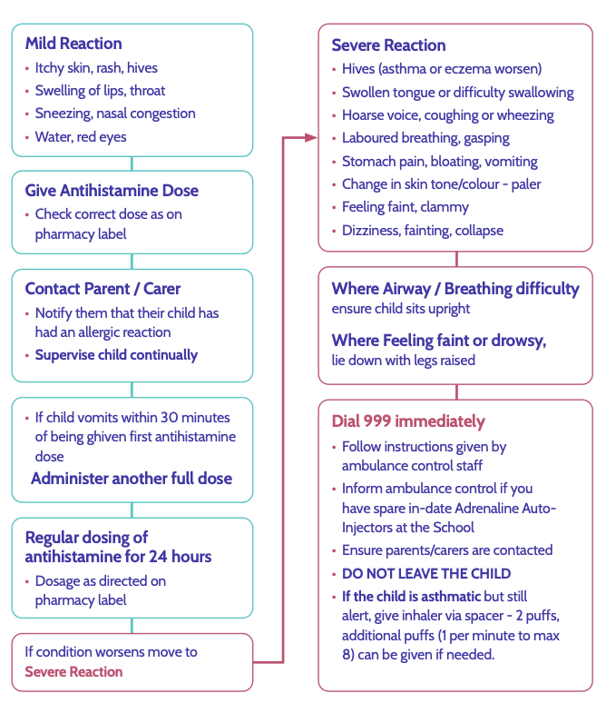

Appendix IV
Flowchart for Allergic Reaction with use of Adrenaline Auto-Injector
Refer to the child’s BSACI Allergy Action Plan if they have one and call for other staff help if needed

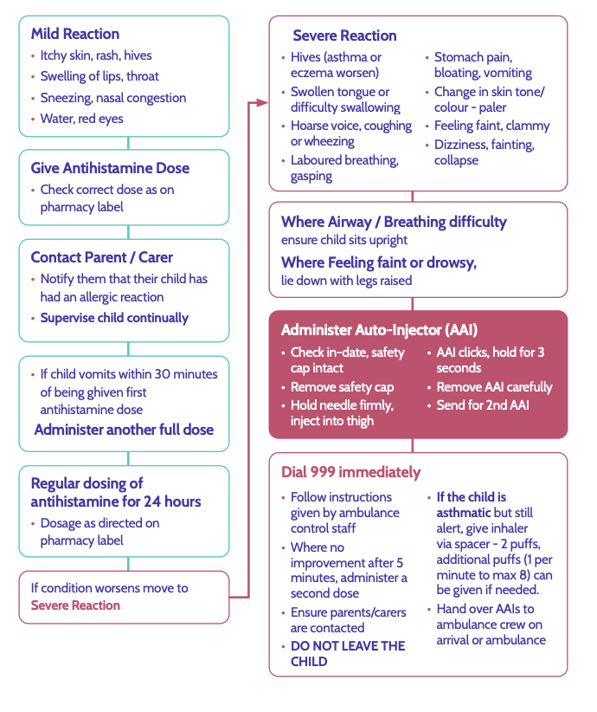

Appendix V
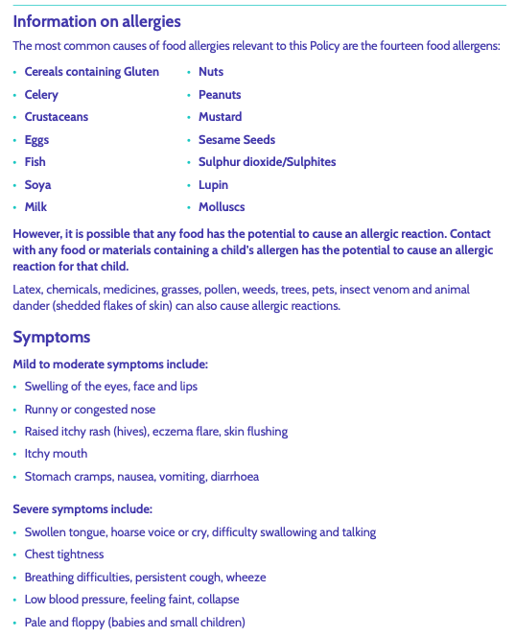

Appendix VI - Top 14 Allergens poster
