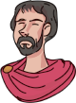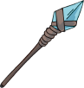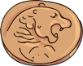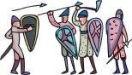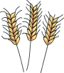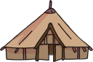

**Year 3 & 4**

The Battle of Hastings

**Mesolithic**

**Neolithic**

**Bronze Age**

**Romans**

**Anglo-Saxons and Vikings**

**Iron Age**

Roman Empire at its height

The Heptarchy

of England

First coins minted

Beaker people

Farming introduced

Stonehenge built

**I am Warrior!**

Roundhouses built

800 BC

2000 BC

4000 BC

10,000 BC

2,000,000 BC

**AD 1066**

**AD 117 AD 500 - AD 927**

**100 BC**

Hunter-Gatherer life

**2000 BC - 1800 BC**

**3000 BC**

**4500 BC**

**Knowledge Organiser**

AD 43

AD 410

AD 1066

**Palaeolithic**

**The Anglo-Saxon Heptarchy**

**Early Rome**

**The Anglo-Saxon Heptarchy**

Over many years, the Romans fought to take control of the **Italian region**. They used three methods of conquest to bring together the different peoples under the banner of Rome:

* Annexation
* Colonisation
* Military Alliance

The end of the Roman Republic eventually came in 31 BCE when the **Battle of Actium** (known as **‘the last war of the Roman Republic’**) was fought between **Octavia, Agrippa and Marc Anthony & Cleopatra**. Octavian and his general, Agrippa, triumphed in battle and as a result Octavian took control of all of Rome’s land and named himself **Emperor Augustus**, the **first emperor of the Roman Empire**.

Archaeologists believe that people have lived in the **Italian region** for over **850,000 years** with there being evidence of **Palaeolithic** life south of the **River Reno**.

Over **849,000 years later**, a famous legend says that a pair of **twin brothers** settled near the **River Tiber**; thus, creating the settlement of **Rome**. This settlement would grow and expand to become one of the **most powerful and largest empires** the world had ever seen. In its early years, Italy was not ruled by a single group. The land had many different people who would invade and rule over others.

At first, the neighbouring Etruscans were the most powerful in the region and it is believed that they ruled over Rome for a short time, until the Romans revolted and established a republic c. **506 BCE**.

Archaeologists believe that people have lived in the **Italian region**

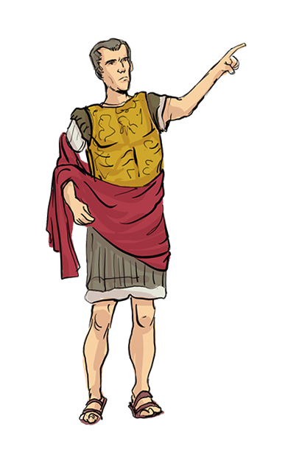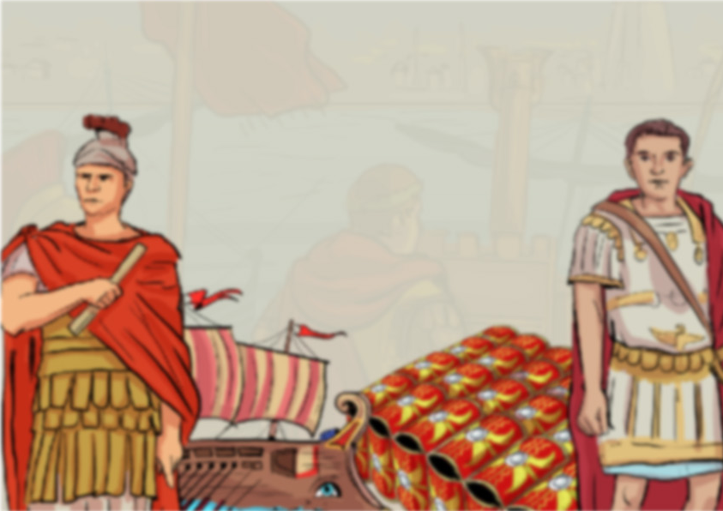

www.grammarsaurus.co.uk

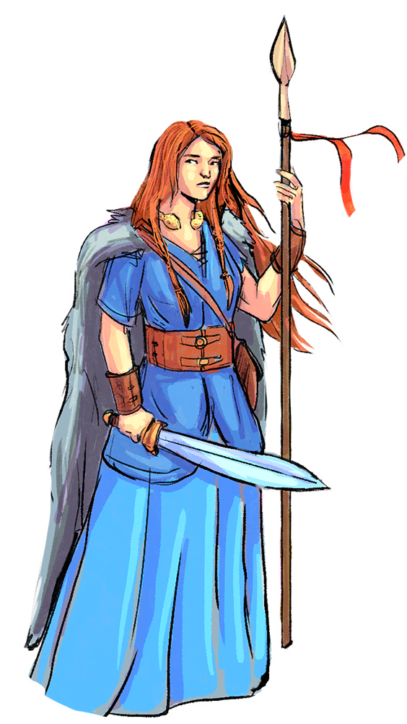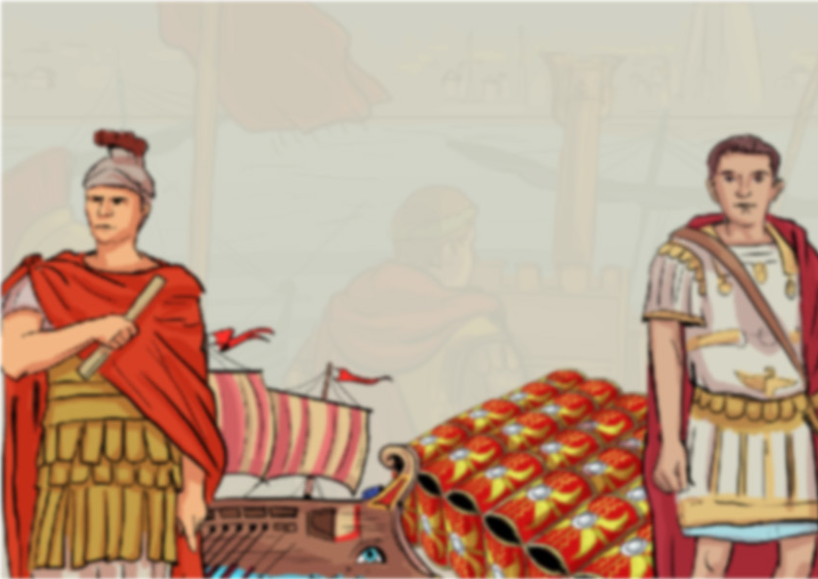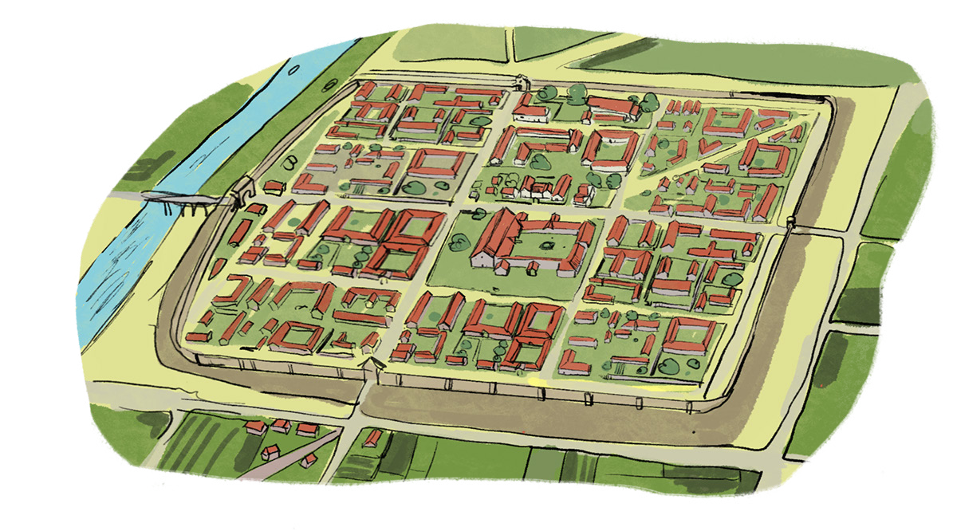

**Roman Britain**

**The growth of the Roman Empire**

**Boudicca** was a **Celtic queen** who fought against the Romans when they came to take her land. Her army **destroyed the Roman cities of Colchester**, **St Albans and London** by burning them to the ground one by one. On her mission across England, she eventually met a Roman legion somewhere in the middle of the country, where she was sadly defeated and Roman reports claim **80,000** of her fighters were killed in battle. Today, she is remembered for her bravery and **fight for freedom**.

**Britannia**.

Under the rule of Emperor Augustus, the Roman Empire had grown and its reach was maintained by Emperor Augustus’ new Imperial Army – an army so well trained and powerful that barely anyone could stand in their way. Augustus and other Roman leaders had eyed Britannia as a way to expand the Empire over the last half a century, but it wasn’t that easy. There had been multiple attempts to invade, but they failed. It took until the year **43 CE** for the Romans to be successful in their quest, and under the rule of **Emperor Claudius**, they invaded and th**e Britons (Celts)** tried to fight back, but were beaten by the heavily armoured and organised soldiers in the **Roman legions**. Within four years, **Rome controlled large regions of Britannia.**

The Romans were not happy just conquering the settlements of Britain – they wanted to turn them into **Roman cities** too. Roman towns in Britain were **full of brick buildings** and temples. The Romans liked everything to be organised, so the **streets** were built in **straight lines**. In the middle of the settlement, there would be a large square called a **forum**. It was used as a **marketplace and for meetings**.

It had **shops and offices on three sides** and **government offices on the other side**. Some towns had **public baths, open-air theatres** (called amphitheatres) and huge **decorative statues**. The buildings were made of **stone and brick**, and many of the buildings were built so well that archaeologists have been able to excavate whole buildings!

**The fall of the Roman Empire**

**Queen Boudicca and her revolt!**

**Civil wars** and chaos erupted across the Roman Empire during the **3rd century**. This crisis saw around **20 emperors rise and fall in just 50 years**! Unfortunately, the problems facing the empire were not only with those trying to rule it. Now, more than ever, forces outside the empire were beginning to make things difficult for the Romans. With all this strain, the Roman Empire started to fall apart, and a man named **Constantine** fought his way to become the single emperor of Rome again – **uniting all Roman lands under him**. He even moved the capital from Rome to a city he named after himself – **Constantinople.** After Constantine’s death, chaos and struggle continued and eventually, the empire would split in half forevermore.

www.grammarsaurus.co.uk



Under the rule of Emperor Augustus, the Roman Empire had grown and it’s reach was maintained by Emperor Augustus’ new Imperial Army – an army so well trained and powerful that barely anyone could stand in their way. Augustus and other Roman leaders had eyed Britannia as a way to expand the Empire over the last half a century, but it wasn’t that easy. There had been multiple attempts to invade, but they failed. It took until the year **43 CE** for the Romans to be successful in their quest, and under the rule of **Emperor Claudius**, they invaded and th**e Britons (Celts)** tried to fight back, but were beaten by the heavily armoured and organised soldiers in the **Roman legions**. Within four years, **Rome controlled large regions of Britannia.**