**MATHEMATICS:**

Reception:

Exploring numbers to 20- number recognition; subitising, number bonds; adding and subtracting; sharing and grouping; even and odd numbers; doubles.

Exploring 2D and 3D shapes- manipulating; composing and decomposing.

Year 1:

Multiplication and division- Counting in 2s, 5s, 10s, grouping; sharing; doubles.

Fractions-recognising halves and quarters of shapes and quantities.

Position and direction- describing turns and position forwards, backwards, left and right.

Place value to 100- counting to 100, partitioning numbers into tens and ones, using number line, comparing numbers.

Money- recognising coins and notes; counting coins.

Time- telling time to the hour and half hour.

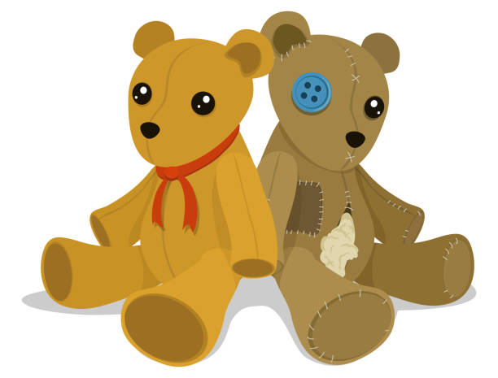

**WRITING:**

We are continuing to use Drawing Club as approach to Literacy. It’s an approach that draws children into the joy of sharing book ideas and exploring writing at their own individual level. Our children are very excited and engaged in this way of learning and we have seen great progress in their ability as well as confidence in writing.

We also have weekly news writing opportunity which helps children with their writing stamina and reinforces writing foundations.

**READING:**

Daily story time- range of books connected to the topic as well as those linked to children’s interests.

Individual books sent home.

Children are invited to choose books form the Library selection at any time and we encourage children to change them independently. Please enjoy sharing those at home.

**SPaG:**

Looking at nouns, verbs and adjectives.

Continue to reinforce using sentence structure, including capital letters and full stops.

Daily phonics lessons.

Practising reading and writing of tricky words.

**TOYS**

**How have toys changed?**

**HISTORY:**

Children will be History detectives finding out about how toys have changed over the years. We will make comparisons between toys in the past and the present, we will look at our favourite toys and those of our parents.

**GEOGRAPHY:**

We will look at our school environment and learn how spring changes to summer and the effects we see all around us.

**SCIENCE:** Materials

Naming different materials.

Distinguishing between an object and the material from which it is made.

Comparing and grouping together a variety of everyday materials on the basis of their simple physical properties.

Investigating properties of material for a specific use.

**Art/DT:** Use a range of materials to design and make. Drawing, painting, mixing colours.

**MUSIC:** Hey You! is written in an Old-School Hip Hop style for children to learn about the differences between pulse, rhythm and pitch and to learn how to rap and enjoy it in its original form. Learning to sing, play, improvise and compose with this song, children will listen and appraise other Old-School Hip Hop tunes.

RE: What is the good news Christians believe that Jesus bring?