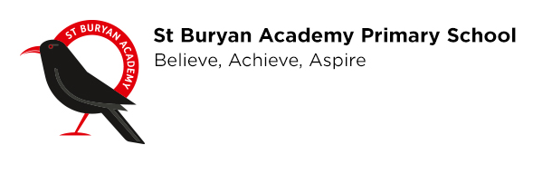
St Buryan Academy Primary School

Dear Parents/Carers,

St Buryan Academy Primary School Wrap Around care – Breakfast Club

‘Breakfast’ Club will run from 8:00am – 8:45am, and the cost per day will be £1.50 per session. For the present time no food will be available to purchase.

To book a place/s please complete the slip below and email back to the office.
We ask for payment in advance. Due to present conditions and to reduce the handling of cash in school, we ask for advance payment direct to the school’s bank account; if this is not possible then a sealed envelope with your child’s name on can be sent in to school with your child. Where possible a month in advance would be appreciated but if not a weekly payment is acceptable. No cash will be handled at the session.

Thank you

Mr J McDonald
Head of School
…………………………………………………………………………………………………
Date:

Name of Child/ren:

Current Year Group/s:

Please tick which sessions you want to book:
Breakfast Club
M | T | W | Th | F

The school’s bank account: Nat West Penzance
60-16-22 Account No 76098079 in the name of St Buryan Academy Primary School. Please put as a reference BC and your child’s initials.

Signed: ……………………………………or type in your name

