**Year 1**

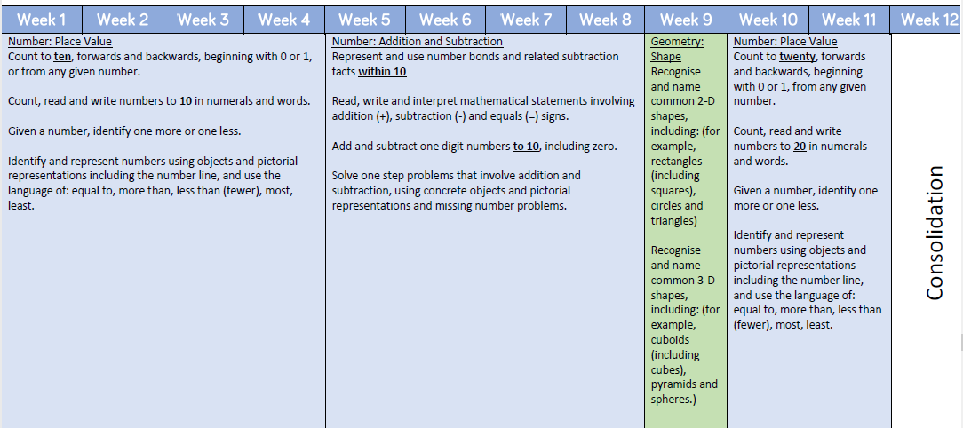

**Year 2**

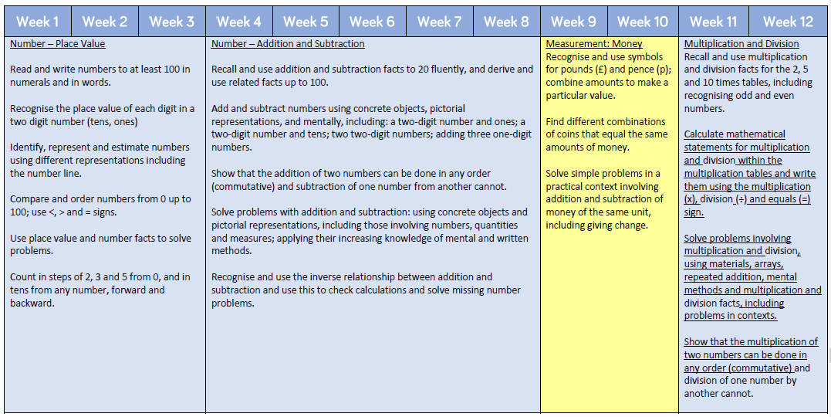

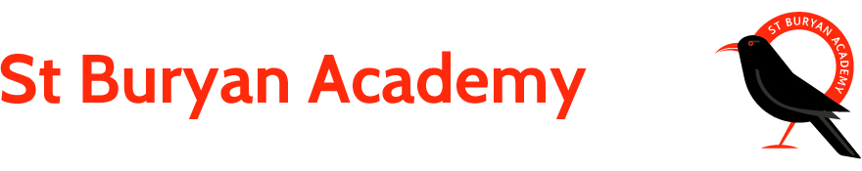

**PSHE/RE**

What do Christians believe God is like?

How was the world created?

Making mistakes is good!

**Science**

Explore a range of materials people use to make structures to shelter, house and transport animals and how the materials are chosen for their qualities. We will hopefully visit a farm to investigate materials used in animal’s homes.

***Gwenver***

***The Big Build***

**ICT**

Search for construction images on the internet, copy & paste them. Add text, save and print.

**Geography / History**

Think about how we use maps, finding places and features on a map, using a key to locate different features, creating our own maps of a real place and a fictional place. Trip to a woodland to build many miniature homes that form a ‘town’ that we can create a map for.

**Art/DT**

Study Native American Wolf Masks.

Design & make abstract wolf masks from card.

Develop 2d & 3d Skills, colour mixing relating to the ‘Three Little Pigs’.

Design and construct our own big build. Plan and investigate different construction methods.

**English**

Learn the story of the Three Little Pigs and retell it from memory. Transform the story to create their own version with a few exciting twists. Label and write captions to a series of images linked to construction.

Write instructions for building a piggy’s house.

**Maths**

**Year 1 –**

Place Value

Addition & Subtraction

Shape

Place Value

**Year 2 –**

Place Value

Addition & Subtraction

Money

Multiplication & Division