BOOKING FORM 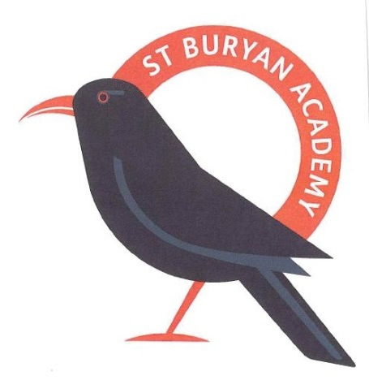
Please complete and return to Little Choughs Nursery at St Buryan Academy Primary School

Personal Details
Child’s Name: |  | Date of Birth:
Full Address:
 |  | Postcode:

(1)Parents/Carers Name: |  | Relationship  to Child:
Email address:
Mobile Number: |  | Work Number:

(2)Parents/Carers Name: |  | Relationship to Child:
Full Address (if different):
 |  | Postcode:
Email address:
Mobile Number: |  | Work Number:

Sessions Requested – We offer a morning session of 9.00am – 12 noon or day session from 9.00am to 3.00pm (Term time only)
Lunch is between 12 and 1pm and can be provided by the School Kitchen at a cost of £2.20 per day or you may bring in a Packed Lunch for your child. Lunch is offered to children who stay for the whole day as from the start of the Spring Term. This has been revised in order to accommodate staffing during the lunchbreak.

Charges are as follows:
£4.00 per hour
We accept the 15 hours and 30 hours childcare funding – if you require information on this please ask at the school office.

Sessions booked will be charged for even if your child is absent. This is to ensure that correct staff ratios are maintained in line with Ofsted guidelines.
Autumn Term  Sessions required – please enter either 9-12 or 9-3pm  Mon Tues Weds Thurs Fri | See over

Once your child is offered a place and you accept it, further personal information and family details are required for our records when your child begins their settling in sessions.

If you find that you no longer need the place, please inform us as soon as possible. Should you decide you no longer need the place we will not retain the details on this application form.

Signed Parent/carer ………………………………………………………………… Date ……………………………………………………………..

We like to regularly update the details we hold on file so thank you for completing the form even if you have done so when your child was first registered.

