**WRITING:**

Persuasive Adverts – explore the features of a persuasive text and write a persuasive advert for a local locality.

Narrative unit – write adventure stories travelling around the world.

Instructions – explore the features of instructions and write our own based on our topic.

**Art**

Explore and develop art techniques from around the world.

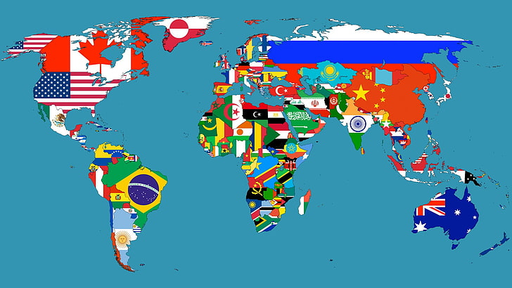

**Our Home**

***Where and what is our home?***

**Showcase: Google Slides Presentations**

**RE:** How and why do people mark the significant events of life?

How and why do people try to make the world a better place?

**SCIENCE:**

We will learn about the properties of different materials and investigate which materials will best for different scenarios like how to protect an egg dropped from a height.

Then we will learn about pushes and pulls as an introduction to forces and how magnets attract and repel at a distance without contact.

**MATHEMATICS:**

Year 2 blocks – Money, Fractions, Time, Mass, capacity and temperature and Position and direction.

Year 3 blocks – Time, Decimals, Money, Shape, Position and direction and Statistics.

**READING:**  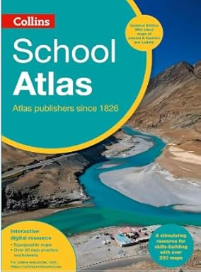 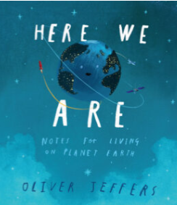

**Geography:** We will name and locate the world’s seven continents and five oceans, name and locate the four countries and capital cities of the UK, understand geographical similarities and differences both human and physical comparing the UK and Brazil, identify seasonal and daily weather patterns in the UK, the location of hot and cold areas from the equator and the poles, read and create maps using keys, understand geographical vocabulary both physical and human, use compass directions and use field work to study our local area.

**PE:** This term we will be covering tennis, striking and fielding games and athletics.