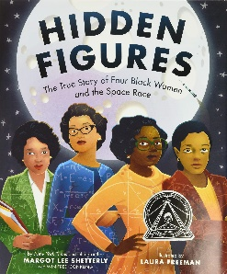

**PE** There will be a focus on the skills required to compete in a range of team games (speed, agility, spatial awareness, accuracy)

We will be swimming after half term.

**Reading**

**Mathematics**

Place value – including comparing and ordering numbers, rounding, negative numbers and Roman numerals.

Addition and Subtraction – formal written methods.

Statistics – reading and interpreting graphs, charts and timetables.

Multiplication and division – X and ÷ by 10, 100 & 1,000, multiples, factors, prime numbers, square numbers and cube numbers.

Measurement – perimeter and area of rectilinear shapes.

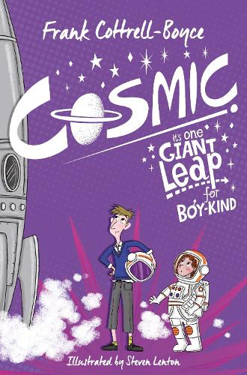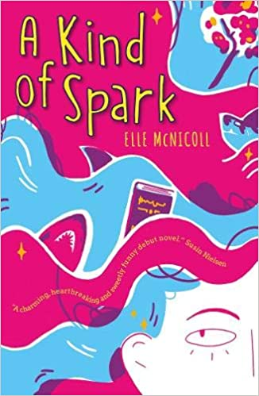



**History**

Significant people - Galileo Galilei, Isaac Newton.

1960s space race with a link to Black History Month

**Geography**

Using maps, atlases, globes and digital/computer mapping to locate countries and describe features.

What does Earth look like from Space? An astronaut's view.

**Computing**

Systems and vector drawing

**Art/ DT**

Tints, Tones and Shades; Cosmic collages and Cams. Food prep and cooking through Forest School

**Music**

Children will use a range of instruments and their voices to compose, perform and appraise.

**Stargazers**

*What is out there?*

*Authentic Outcome: Stargazing evening and gallery*

**Writing**

This term we will focus on the following areas:

* Instructions
* Narrative with a focus on character and setting description
* Poetry – Space themed
* Biographies
* Story writing

We will also be recording our learning in other curriculum subjects including writing up our science experiments, making notes and recording our thoughts and ideas.

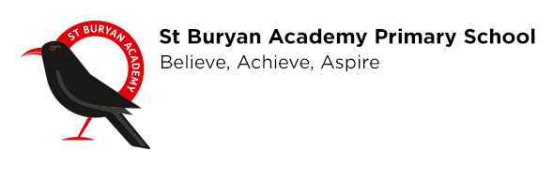 

**Religious Education**

What does it mean if Christians believe God is holy and loving?

What does it mean to be a Muslim in Britain today?

**PSHE**

Children will learn about how to care for themselves and others. How to show respect and stay safe in person as well as online.

**French**

Geography, days, months, numbers and All About Me.

**Science**

**Earth and space:**

Describe the movement of the Earth, other planets and the moon, explain day and night and the apparent movement of the sun across the sky.

**Forces**: gravity, leavers, pulleys and zip-wires.

**SPAG**

**Spellings** will be taught daily in class through a variety of engaging investigations.

**Punctuation** focus:

Comma’s in a list and colons to introduce a list, semi-colons to link clauses.

**Grammar** focus for this term:

Sentence structure and word classes, conjunctions, imperative verbs, expanded noun phrases, adverbs of time and manner.