**MATHEMATICS:**

Match, sort and compare.

Talk about measure and patterns.

It’s me 1, 2, 3

Circles and triangles

1, 2, 3, 4 and 5

Shapes with 4 sides

**SCIENCE:**

We will identify and name a variety of common animals including fish, amphibians, reptiles, birds and mammals, identify and name a variety of common animals that are carnivores, herbivores and omnivores, describe and compare the structure of a variety of common animals, identify, name, draw and label the basic parts of the human body and say which part of the body is associated with each sense. We will have a deeper focus on aquatic animals.

**RE:** What do Christians believe God is like?

Why does Christmas matter to Christians?

**Art :** We will use monochromatic to explore drawing and painting to develop and share their ideas, experiences and imagination. We will develop a wide range of art and design techniques in using pattern, texture, line, shape, form and space.

**Geography:** We will name and locate the world’s seven continents and five oceans, name and locate the four countries and capital cities of the UK, understand geographical similarities and differences both human and physical.

**Under the Sea !**

***What lives within the ocean?***

**Showcase: A classroom aquarium.**

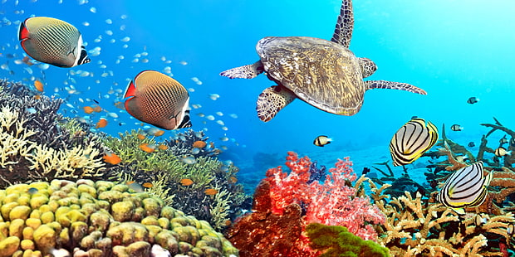

**EYFS Writing Goals:**

Write recognisable letters, most of which are correctly formed.

Spell words by identifying sounds in them and representing the sounds with a letter or letters.

Write simple phrases and sentences that can be read by others.

**Writing**

Mark making through various forms. Write their names with accurate letter formation. Secure the first 26 phonemes and form them accurately.

**READING:**  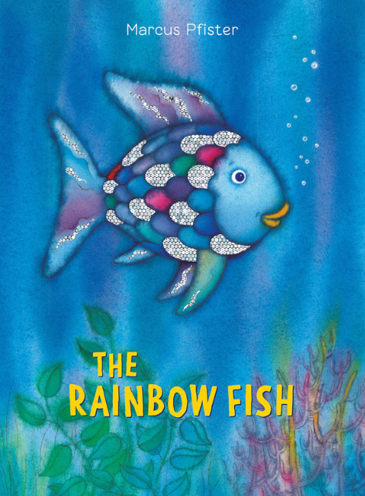 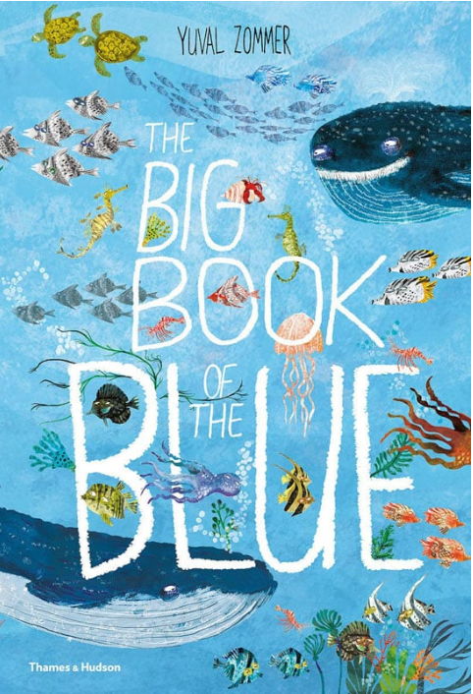

**PE:** We will be covering team games with a focus on ball techniques and then a unit of football.