**Mathematics**

Place value – including comparing and ordering numbers, rounding, negative numbers and Roman numerals.

Addition and Subtraction – formal written methods.

Statistics – reading and interpreting graphs, charts and timetables.

Multiplication and division – X and ÷ by 10, 100 & 1,000, multiples, factors, prime numbers, square numbers and cube numbers.

Fractions – finding equivalents and converting between improper fractions and mixed numbers. Calculating fractions using the 4 operations.

**PE and Outdoor Learning**

Tuesday - Hockey (1st Half term) then Netball (2nd Half term)

We will be swimming on a Thursday – please see the newsletter for dates.

**Reading**

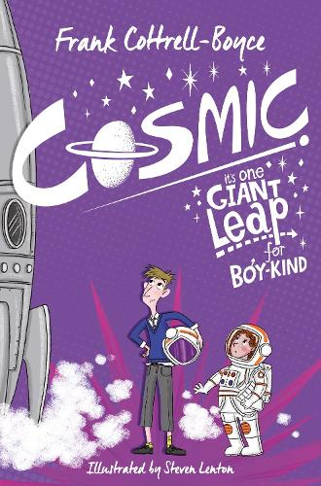



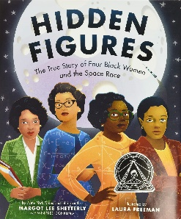

**Writing**

This term we will focus on the following areas:

* Punctuation and Grammar
* Instructions
* Narrative with a focus on character and setting description
* Poetry – Space themed
* Memoirs

We will also be recording our learning in other curriculum subjects including writing up our science experiments, making notes and recording our thoughts and ideas.

**Reading** will be taught through daily guided reading sessions through the class novel ‘Cosmic’ and shorter texts covering a range of themes.

**SPAG**

**Spellings** will be taught in class and sent home to reinforce. Informal quizzes will be used as assessment.

**Punctuation** **and Grammar** will form the focus of the first three weeks of teaching then will be embedded within the writing genre lessons.

**Stargazers**

*What is out there?*

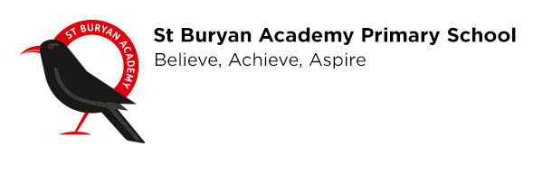 

**Religious Education**

Creation and science: conflicting or complementary?

How do Christians decide how to live? ‘What would Jesus do?’

**PSHE**

Children will learn about how to care for themselves and others. How to show respect and stay safe in person as well as online.

**Science**

**Earth and space:**

Describe the movement of the Earth, other planets and the moon, explain day and night and the apparent movement of the sun across the sky.

**Forces**: gravity, leavers, pulleys and zip-wires.

**History**

Significant people - Galileo Galilei, Isaac Newton.

1960s space race with a link to Black History Month (October)

**Geography**

The economic activity of the UK

**Art** ‘I need space’ – focus on drawing.

**DT** Mechanical systems – Automata toys (cams)

**Music** Charanga Music curriculum:

Interesting Time Signatures (4)

Combining elements to make music

**Computing** Computing systems and networks – The Internet

**French (2nd half term)**

Alphabet, well known stories, towns and directions.