Name | Write your name here
I attended St Buryan in… | The years you attended St Buryan go here
My favourite thing about St Buryan school was/is… | Your favourite thing about our school goes here
My favourite memory from St Buryan is… | Your favourite school memory goes here
I am now a/an… | Your current job/career (or previous job/career) goes here
I wanted to do the job I do/did because… | Why did you want to do the job above?
What I had to do to get my job… | Write what training/qualifications/skillset you needed for your job here
When I was in primary school I wanted to be a/an… | Put what you wanted to be when you were younger here.
My advice for children currently in school is… | If you have any good (and suitable!) advice for our children, put it in here!
Have you got a picture of yourself at school?
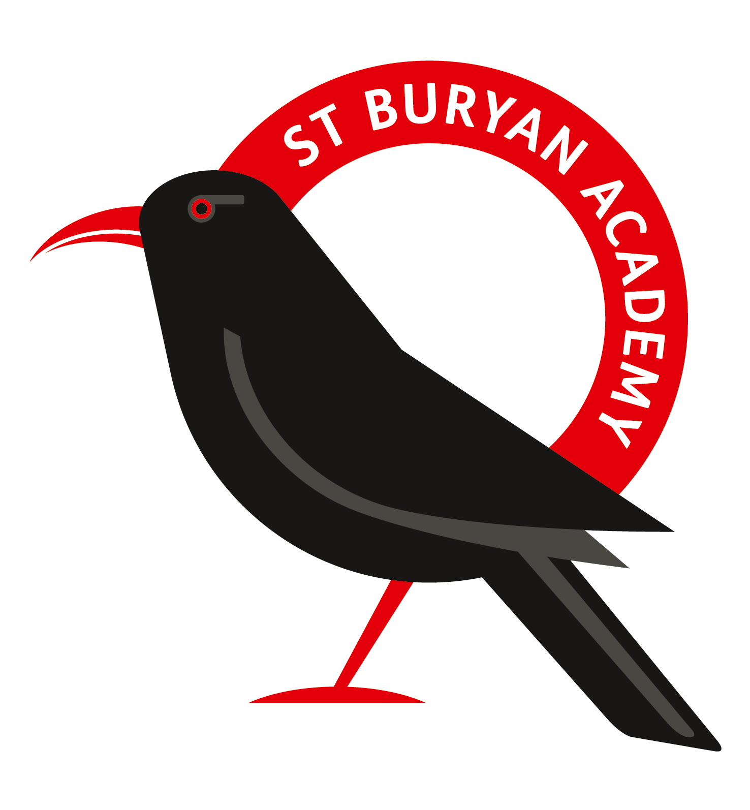
If you would like to, you can put a picture of yourself here or you at work!

