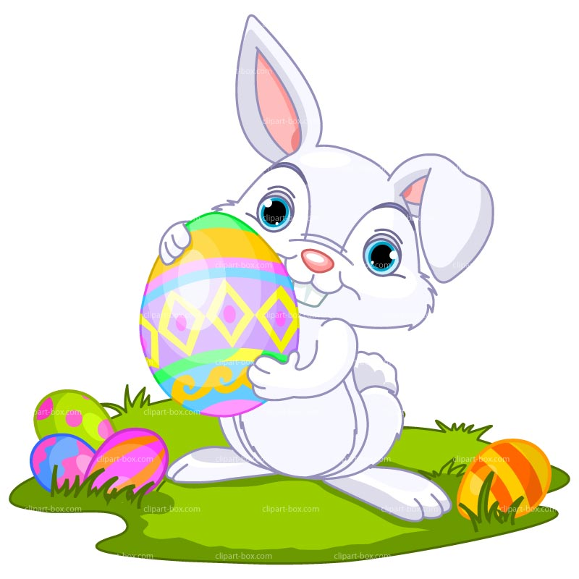
Easter Egg Lucky Square WINNERS- Thanks to everyone who supported
- Edward Martin
- Amilie Mottram
- Jayden Cheel
- Cadan Bone
- Joseph Kinver
- Eli Jackson
- Grace Bolitho
- Finlay Harry
- Joby Breslaw
- Charity Britton
- Harry Murrish
- Alfie Pilkington
- Cadan Bone’s cousin, Emily
- Cerys Wallis
- Emma Marment
- Rose-Marie Murley
- Luke McWilliam
- Tom Holbrook

