Class | Year | Teacher | Email
Penberth | Rec. & Y1 | Mrs N Cross  Mrs J Kwiatkowska | ncross@stburyanacademy.org  joannak@stburyanacademy.org
Gwenver | Y2 | Mr J McDonald | head@stburyanacademy.org
Nanjizal | Y3/4 | Mrs L King | lking@stburyanacademy.org
Porthcurno | Y5/6 | Mrs O Connell  Mrs L Rendle | oconnell@stburyanacademy.org  lrendle@stburyanacademy.org
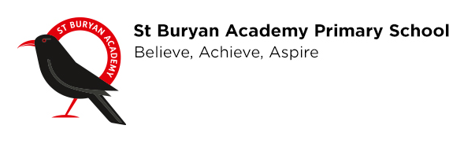
Following the Government guidelines to close all schools, we are putting together home learning packs for your child to complete whilst self-isolation is taking place. As it is still term time, children will be expected to complete this work. This is a Government expectation. Work will be sent out on a weekly basis and fit the needs of their current learning. Should you require any further information on the work set, then please contact your child’s class teacher through email, but please be mindful of recognised working hours; they will reply when they can.
Useful websites
Here are some useful websites that will encourage and support your children’s learning:
Times Tables Rockstars – a great way of learning and reinforcing times table knowledge for years 2-6.
www.play.prodigygame.com – interactive maths games
www.whiterosemaths.com – maths challenges that tie in with our curriculum
www.phonicsplay.co.uk – word and sound games
www.teachyourmonstertoread.com – a great reading website for all
www.literacyshed.com – a great website that has lost of stimulus for creating stories
www.uk.ixl.com – lots of quizzes
www.twinkl.co.uk/offer - enter the code UKTWINKLHELPS for loads of free learning resources for every subject!
www.bbc.co.uk/bitesize - the BBC Bitesize website has loads of informative games, videos and revision for all children, especially those who will be doing their Year 2 and Year 6 SATs.

I also strongly advise that you sign up for: https://kids.classroomsecrets.co.uk/ This gives you and your child access to lots of free learning resources to fit their current learning and needs.

All of these websites are great to use at any time, so if you ever need any additional learning or have some free time, these are great websites to start with!

Teachers have put together learning packs for your children to complete. We will be using Google Classrooms to upload and respond to work set as outlined in a previous letter.

The school will keep you updated with any further information on a regular basis.
Thank you

Mr McDonald

