**Mathematics**

Our maths lessons this term will focus on calculating fractions and finding fractions of an amount.

Decimals and percentages.

Units of measure, area and perimeter.

Yr 6 will be introduced to algebra and ratio.

Multiplication and division will be a focus for year 4.

**PE & Outdoor Learning**

Rugby and Football

Dance

Swimming

Forest School will take place in the 1st Half term.

**Reading**

Class

Reads:

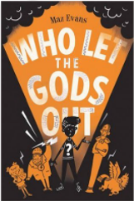

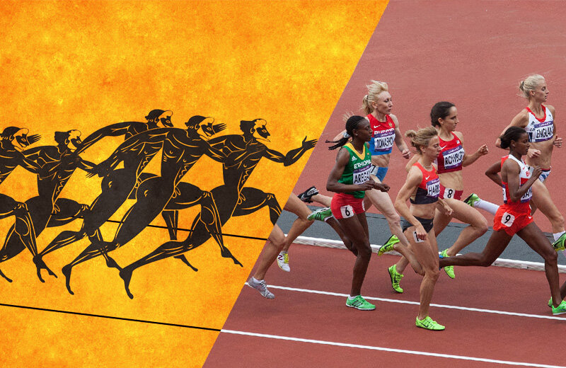

**Blood, Sweat and Tears**

*What powers us?*

*What did the Ancient Greeks do for us?*

*Authentic Outcome: Mini Olympics*

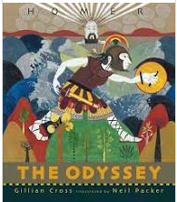

**Science**

**The circulatory system:**

Identify and name the main parts of the human circulatory system, and describe the functions of the heart, blood vessels and blood, recognise the impact of diet, exercise, drugs and lifestyle on the way their bodies function and describe the ways in which nutrients and water are transported within animals, including humans

**Writing**

This term we will focus on the following areas:

Whole School Writing Project based on ‘The Lost Words’ poetry book by Robert Macfarlane

Narrative with a focus on Greek Myths based on The Odyssey by Homer.

Explanation Texts focussing on the circulatory system.

Information texts based on mythical creatures.

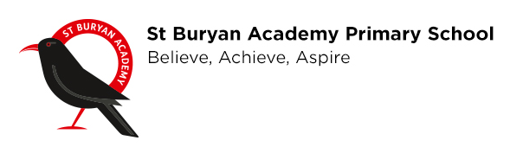 

**Religious Education**

What do Christians believe Jesus did to ‘save’ people?

For Christians, what kind of king was Jesus?

**PSHE**

Children will learn about how to care for themselves and others. How to show respect and stay safe in person as well as online.

**French**

Grammar- Adding adjectives- agreement

Clothing- winter/summer clothes I am wearing… he/she is wearing + adjective (colour)

Culture/Knowledge about France- Easter traditions

Basics- Numbers 31, months of the year, date

Revisit- feminine/masculine, alphabet, spelling known words, colours, days of the week, songs.

**History**

Ancient Greece – Who were the Ancient Greeks and how do their achievements influence on the western world today?

Significant people – Alexander the Great, Socrates, Aristotle, Pythagoras

**Geography**

Using maps, atlases, globes and digital/computer mapping to locate countries and describe features.

**Computing**

Creating media - web page creation

**Art/ DT**

Greek Vases and Constructing pavilions.

**Music**

Developing pulse and creating simple melodies. SongFest

**SPAG**

**Spellings** will be taught weekly in class following Spelling Shed.

**Punctuation** focus:

Using a variety of punctuation accurately within our writing.

**Grammar** focus for this term:

Sentence structure and word classes, conjunctions, expanded noun phrases, adverbials. SATs preparations for year 6.