Dear Parents and Carers,
Welcome back to the Autumn term. We hope that you have enjoyed the Summer break. Thank you for the many positive comments regarding how welcoming our classrooms look; staff have worked hard over the holiday to ensure that all our classrooms are stimulating working environments for their classes- grateful thanks to them for their efforts.
New Outdoor Learning Classroom
You will no doubt have noticed that the building of our new classroom, sited in the school garden area, is now nearing completion. This new building will provide great outdoor learning opportunities for the whole school and our hope is that it will become a valued community resource too.
Y5 Girls summer Science camp
Congratulations to Thea who took part in this year’s Girls Summer Science Camp run by Nexus (based at Camborne School) which really challenged all the girls who participated. Thea was awarded one of the top three prizes, ‘Most Promising Young Scientist’, due to the precision of her work in the lab and can recommend the activity to any girls who may be interested in taking part in the future.
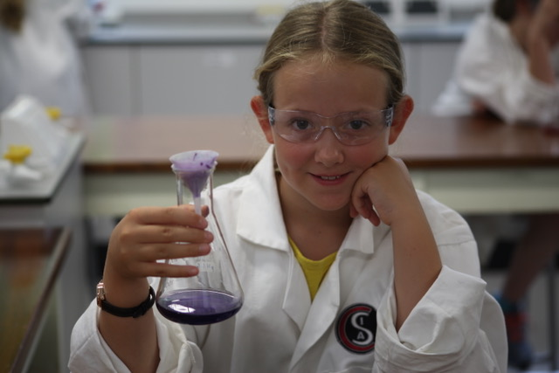
Alumni: We are always delighted to hear from past pupils and I was thrilled to catch up with some familiar faces over the summer break. You may well remember that local bluegrass band ‘Flats and Sharps’, with our ex-pupil Mikey Ponsford on mandolin, entertained us all at the official opening of the conservatory in 2011. Since then the band have travelled the world, developing into impressive instrumentalists and performers and are currently raising funds to travel to the USA where they have been invited to perform at several festivals. Here they are performing at the Acorn Theatre, Penzance.
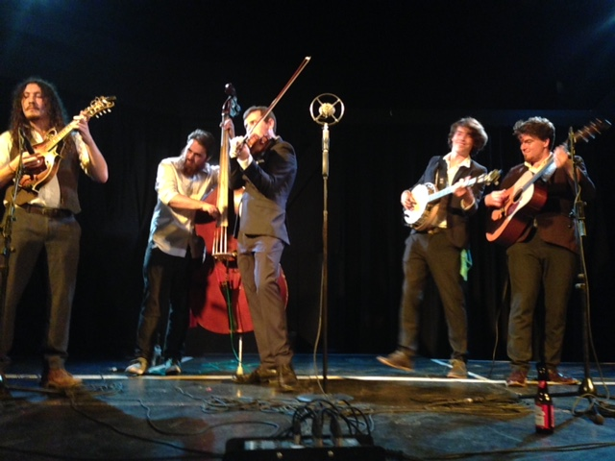
Their warm up group included Abby Thomas (below, centre), another ex-pupil who is about to follow her dream and study Song Writing at Bristol. It is always great to know that past pupils are achieving our school’s mission statement: ‘Believe, Achieve, Aspire’

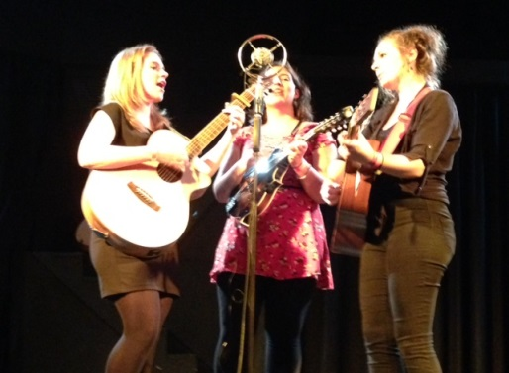
Calendar Dates:
Dates for this term and beyond are available to view on the Calendar section of the school website. You will notice that there are 2 Inset days listed on 19th and 20th October; these non-pupil days will link into our autumn half term break.
Should any family be looking to book an autumn break this will provide a great opportunity to book a holiday at a lower price than a break which falls entirely within the half term holiday!
Crochet Club: Do you have any unwanted wools, suitable for crochet?
Mrs Wilson is beginning a new Crochet Club next week and would be very grateful for any unwanted wools, crochet hooks, etc. Thank you.
Next week’s menu: WEEK 1, Tuesday amendment - PASTY PIE
see website, PARENTS, School Meals
Extra-Curricular Activities; Breakfast Club from 8am all week- last food orders 8.40am
Monday- Construction Club (Y1-2) until 4pm, KS2 Dodge Ball (Y3-6) until 4.15pm
Tuesday- Let’s Get Cooking Y5 Group 1
Wednesday-KS1 Ball Skills (Y1-2) until 4pm, KS2 Ball Skills until 4.15pm
Thursday- Football Club (Y3-6) until 4.15pm

Activities R Us – Short Stay Session to 4.15pm only £2.00 full session until 5.30pm £4.00
Monday- Make n’ Bake- Sausage Rolls
Tuesday- Modelling Clay Fun
Wednesday- Board Games
Thursday- Junk Modelling
Friday- Kite Making

