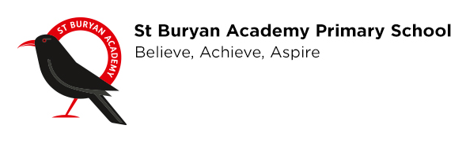
Important information regarding health and hygiene
12.03.2020
Dear Parent/Carer

We are committed to the safeguarding of our children here at St Buryan Academy in every aspect, therefore, I have taken the measures to ensure that health and hygiene measures are enforced and carried out effectively.

As well as health and hygiene being an important part of the school curriculum, we are acting on advice from Public Health England and we would be grateful for your support at this time.

As on last week’s newsletter (Friday 6th March 2020), we would appreciate it if you could reinforce these main points with your children:
- Catch any sneezes with a tissue, bin it and kill it by then washing hands
- Wash hands with soap and warm water after play, cooking or eating and after using the toilet
- Try not to touch your face
- Respect other people’s personal space
- Do not share items such as cups or water bottles

We would be extremely grateful if you could provide your child with a water bottle.

Further to this, we will be enforcing the following:
- Children are to wash their hands upon arrival to the school:
-Those attending Breakfast Club may wash their hands when they arrive
-Year 5 and 6 may wash their hands when they arrive from 8.45
-All other children may wash their hands when directed to do so by a member of staff
- Parents should not enter the main school building during the school day – this includes when dropping off and collecting, unless otherwise agreed.
- When collecting children from any after-school club parents should not go into any classrooms.
- If entering the main school building for any reason during the school day or for upcoming parental interviews, please wash your hands in the staff toilet facility upon arrival.

We will be closely following the relevant guidelines so would therefore like to make sure that all contact information is correct. Please fill in the attached form confirming your:
- Home phone
- Mobile phone
- Email address

Use of mobile phones
This is a polite reminder that the use of mobile phones is prohibited on our school site. This includes the playground area at drop-offs and collection times as well as when collecting from any after-school clubs.
We respectfully ask that if your mobile phone is brought onto the school site that it is not used.
If coming into the main school building for any reason during the school day (assisting with reading etc.) that your mobile phone is left with Mrs Care in reception.
Thank you.

We appreciate your co-operation, please fill in the attached form and return as soon as possible.
Thank you

Mr McDonald
Head of School
head@stburyanacademy.org

Child(ren) name(s):

Name(s) of parents/carers:

I confirm that I received the letter regarding health and hygiene dated 12/03/2020 (please tick)
My updated details are:
Home phone:
Mobile phone:
Email address:
I give consent to St Buryan Academy contacting me for school related matters through the above contact details YES / NO

Signed:
Date:

