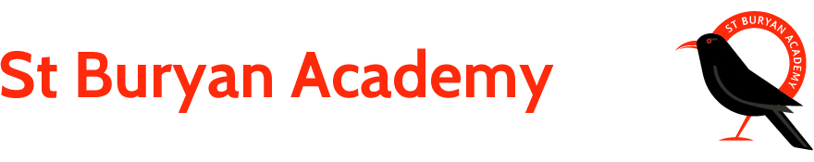

**Science**

Identify and name a variety of common animals including fish, amphibians, reptiles, birds and mammals and know whether they are carnivores, herbivores and omnivores.

Describe and compare the bodies of a variety of common animals.

Discuss animal habitats and us this to identify and name a variety of common wild and garden plants, including deciduous and evergreen trees.

**English**

Write Newspaper reports.

Create fire safety posters.

Learn/Write/alter songs and poems.

Read and Write diary entries.

Read and respond to a range of non-fiction texts.

Write recipes and instructions for our baking.

Use drama to produce a re-enactment of the Great Fire of London.

**ICT**

Search for information & images on the internet, copy & paste them. Add text, save and print.

Internet Safety.

**RE**

**Cornwall as a place of spiritual inquiry**

The marks left on the landscape which makes us ask questions, such as why are there:

Celtic crosses

Special people such as St Petroc, St Piran and the Cornish saints, Standing stones

**The Christian way of life** Famous people who set an example for others to follow e.g. saints

**Geography / History**

*Find out more about how we fight fires today compared with how fires were fought in the 17th century.*

*Learn about the food eaten at the time and contrast the diet of the rich and poor. Compare and contrast contemporary and period recipes.*

*Understand how the Great Fire of London started and what the results were.*

*Find out about the famous diarists Samuel Pepys and John Evelyn.*

***Gwenver***

***The Great Fire of London***

**Art/DT**

*Make 3D models and 2D collages of Tudor homes, and re-enact the Great Fire of London! Finally, a visit from ‘Mr Pepys’ will be the catalyst for the class to become estate agents!*

*Develop their ideas about St Paul’s Cathedral using drawing, imagination and communication; use charcoal drawing and potato printing to develop artistic ideas inspired by St Paul’s before designing, making and decorating a final model Cathedral.*

*Study the Great Fire monument in London and build your own structure to symbolize this historic event.*

**Maths**

**Year 1 & 2 –**

Multiplication and division

Fractions

Length & Height

Mass, capacity & Temperature