d
The Anglo-Saxons and Vikings
What did England change during the settlement of the Anglo-Saxons and Vikings?

Maths
We will start this term with a unit on place value followed by addition, subtraction, multiplication and division.
The remainder of the term will focus on fractions including finding equivalents, simplifying fractions and calculating fractions.
Maths lesson will include a 15 minute focus on arithmetic and rapid recall of times tables & number facts followed by an hour on the focus objective for the day including a range of fluency, problem solving and reasoning questions.

Reading/ Class Novel
Our class novel this term is ‘Anglos Saxon Boy’ by Ross Welford.
We will also cover year 5/6 texts as part of our whole class reading sessions. We will focus on VIPERS – Vocabulary, Inference, Predictions, Explanation, Retrieval and Summarise. We will read a variety of fiction, non-fiction and poetry, which will link to termly themes.

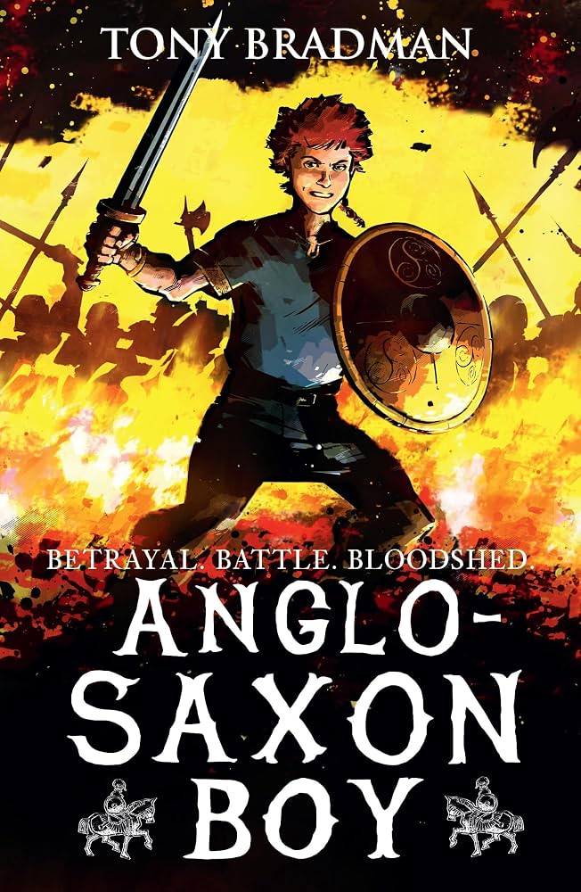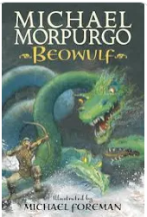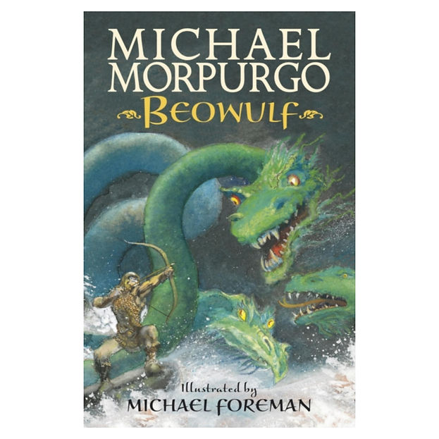
English
Our updated writing curriculum will focus on two key areas:
Character descriptions - children we will learn how to describe a character’s appearance, personality and actions using rich vocabulary and well-chosen detail. Our focus text will be: Beowulf by Michael Morpurgo.
Diary entries - pupils will write in role as characters from the text, developing their ability to express thoughts, feelings and experiences in a clear, personal voice.
These units will support children in building stronger sentence structure, developing imaginative ideas and improving overall writing stamina.

History/Geography
This term we will learn about the Anglo-Saxons and Vikings and how they were much more than raiders - they were skilled sailors, traders and settlers who had a lasting impact on Britain. Pupils explore their achievements from 410CE to 1066CE. Pupils will learn why the Vikings travelled to new lands and what everyday life was like in Viking communities. They also learn about key figures such as Alfred the Great and discover how Viking culture, language and place names still influence Britain today.
PE:
We will be learning the fundamental skills involved in hockey and football this term. We will also be swimming on a Thursday afternoon.
Music:
This term we will focus on patterns in music.
Computing:
Use technology safely, respectfully and responsibly.
Art/ DT:
Monochromatic – observing and drawing the features of the face.
Viking shields – designing, layer, strengthen and decorate Viking shields.
French:
Our wonderful bilingual teacher, Mrs Wilson, will be teaching our French lessons.

Science
Animals including humans – A study of animals with a focus on the skeletal system.
States of Matter – A study into how materials behave as solids, liquids and gases.

RE:
What do Christians learn from the Creation story?
What is it like for someone to follow God?
PSHE:
Dreams and Goals – Aspirations, how to achieve goals and understanding emotions
Being Me in My World – Who am I and how do I fit?

This term
Sporting opportunities – Cross Country and Hockey League.

